The raw data for this exercise is from a ray tracing simulation done with a model of central location in Otaniemi. The model was downloaded from Open Street Maps and all the building walls were set to be concrete, roofs metal and ground as (MATLAB) loam in Blender software. The antenna was left as ideal isotropic so we can add any antenna in the post processing. We used two different ray tracing tools: MATLAB and Sionna. The simulated area is 132x147 meters and the simulation was done between 3069 receive and 9 transmit locations. The simulation was done with uniform 2.5-meter grid which gives each location 8 equidistance neighbors. This needs to be considered when later evaluating the performance of identifying neighbors. Maximum number of reflections was set to four and the maximum number diffractions to two with the center frequency of 3.6GHz. This typically generated hundreds of paths per link in this environment.
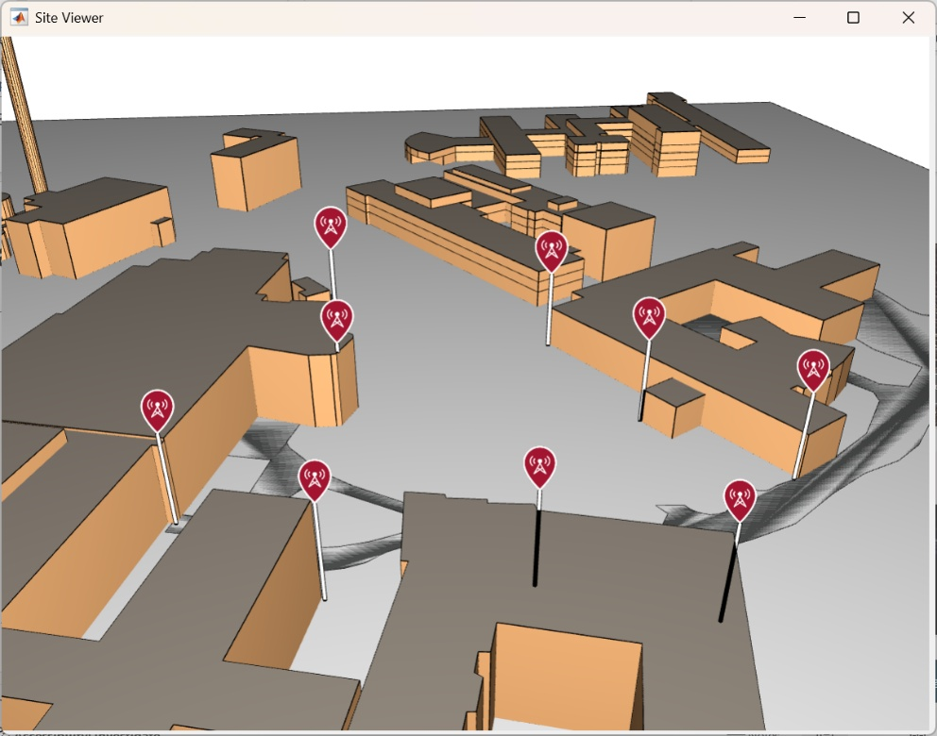
Figure 1. Simulated environment.
3096x9 simulation outputs were saved into individual json files that were then consolidated into one 3096x9x5x40 matrix containing selected information of 40 strongest paths from the raw data. The four kept vectors are: path real part, imaginary part, azimuth angle of departure, elevation angle of departure and path delay. The departure angle was used since we are later modelling signals coming from the user equipment. This RT matrix was then saved into a file that could be used with our feature creation algorithms. The feature creating algorithms can truncate the 40 path long vectors to a more suitable length N, parameter used in the equations below.
Ray tracing outputs themselves cannot be used as features since the real base station would not have access to the signal in this format and fidelity. This raw data must be then converted into real world receiver data. The base station has access to two useful data vectors: (OFDM) CSI and (carrier) amplitude and phase of each antenna, ASI. We convert the RT matrix into these two real world data vectors for the feature creation.
We calculated Antenna State Information for antenna n,m as
$ASI[n,m]=\sum_{i=0}^{N}{a_{i}e^{λj(m∙sin\left(θ_{i}\right)\sin\left(φ_{i}\right)+n∙sin\left(θ_{i}\right)\cos\left(φ_{i}\right))}}$, where λ is the antenna spacing in radians and a, φ and θ are path complex amplitude, azimuth and elevation angles from the RT matrix. We calculated the response for various ULA and URA arrays for comparison. The antenna response itself can be used as a feature in the form of flattened covariance matrix, or log-eucledian distance matrix between all receiver locations (3096 x 3096). Our antenna program generates both matrices.
While the antenna response covariance matrix can be used directly, the useful information that it contains is in the angle of arrival. This means that the antenna data can be compressed into more compact form that, not only makes a smaller feature set, but also suppresses a lot of noise and unnecessary information. While the original RT matrix contains all this arrival angle information, it is not with a realistic resolution that the base station antennas can see. The green plot below in Figure 2 illustrates how coarse the actual angle resolution is compared to the infinite resolution of the ray tracing.
We used Capon (Minimum Variance Distortionless Response) energy direction finding in 2D and 1D to calculate more realistic arrival angles. Unless massive antenna arrays are used, only the strongest direction contains useful information since the weaker paths are mostly convoluted with the wide shoulders and sidebands of the main beam. The path phase contains no coherent information, so it was also discarded.
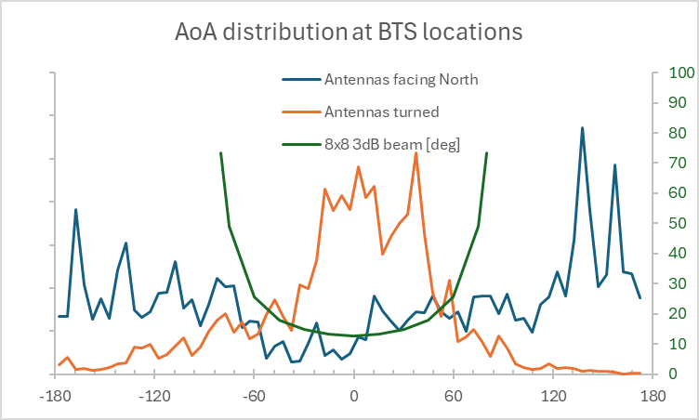
Figure 2. Illustration how antenna orientation matters when wide beams are used.
As Figure 2 above shows, the beam resolution gets worse when turning away from the antenna broadside, so the antennas were turned towards the center of the area in interest. The figure also shows how the azimuth angle distribution matches much better with the accurate angle region after turning the antennas. We also allowed reception from the back side of the antenna in the finger printing case. If the back side has strong radiation, then those paths are aliased to the front side in the direction detection. In multi-angulation the antenna was considered to have 180-degree sector, so no back radiation was allowed.
MATLAB Phased Array library has MVDREstimator2D() function, but it turned out to be performing poorly with the data from the Ray Tracing. So, the arrival angle estimation was done in Python.
We calculated the CSI as $CSI[n]=\sum_{i=0}^{N}{a_{i}e^{j{(n2πf}_{s}τ_{i}+φ_{i})}}$, where f_{s} is 15kHz and n goes from 0 to 6323. Amplitude a_{i} and phase $φ_{i}$ are from the RT matrix. τ is also from the RT matrix but the true distance is first subtracted from it and then a random number [0,10ns] is added to mimic a real receiver sampling. This will also prevent the (unknown) true distance from entering the learning. All the LTE and 5G variants can be subsampled from this CSI vector. Again, the CSI can be used as a feature on its own. If the CSI is used, then it can be further down sampled since the coherence bandwidth is way larger than the subcarrier spacing. Also, absolute value is as good as the full complex. The useful information that CSI contains is in the path delays, amplitudes and (relative) phases. We used Matrix Pencil algorithm to compress and extract the path information from the CSI. Delay statistics like mean delay spread and spread variance can be then calculated from the extracted path information. Also, the strongest three paths are saved as feature candidates. Strongest path time rank was calculated after removing paths that are 10dB or more below the strongest.
All the possible options to create features from the simulation are illustrated in Figure 3. Both the antenna and the frequency domain branches add noise to the signal too. This is especially important in the frequency domain branch where the path extraction would otherwise return the ideal ray tracing results due to the large number of subcarriers. In the antenna branch the low number of antennas is more limiting factor. Still, some diagonal loading needs to be done in Capon algorithm to avoid singular matrices in good SNR samples. Also, some spatial smoothing was needed since the paths correlate due to being from a single signal source.
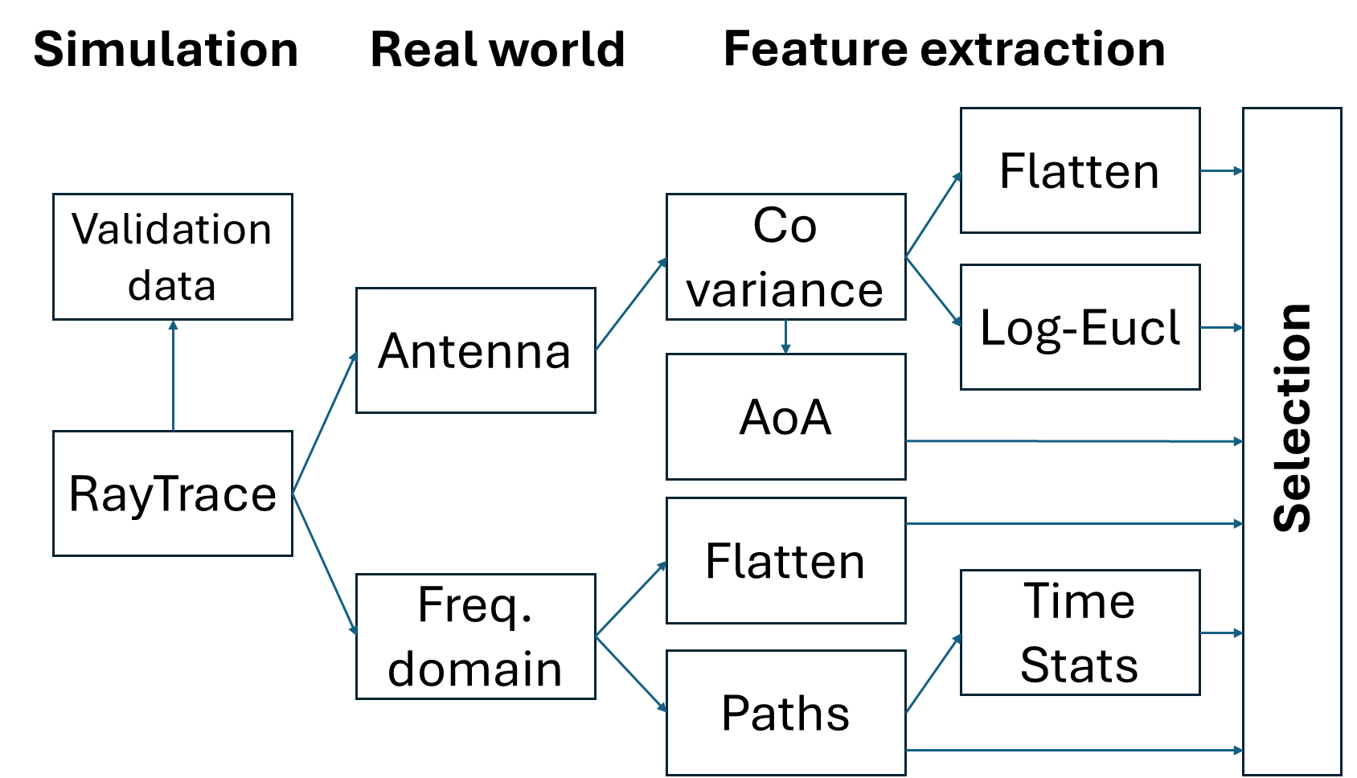
Figure 3. Workflow for creating the features.
The list of all features available for the selection:
Features:
Antenna_aoa: ue_count x bts_count x [azimuth,elevation,amplitude]
Antenna_cov:ue_count x [ant_count x bts_count]
Antenna_log_euc: ue_count x ue_count
Channel stats: ue_count x bts_count x [mean_del_spr, del_spread_var, strong_idx, rss ,del[0], amp[0], del[1], amp[1], del[2], amp[2]]
Csi: ue_count x bts_count x [real x 798, imag 798], 50 MHZ/60kHz
Validation: ue_count x [x,y,bts_count,los_present]
Input data from Ray Trace: ue_count x bts_count x [real x 40, imag x 40, azimuth x 40, elevation x 40, delay x 40], zeros(5,40) if no basestation seen

